1. SELECT * FROM `obat` ORDER BY pembuat_obat ASC

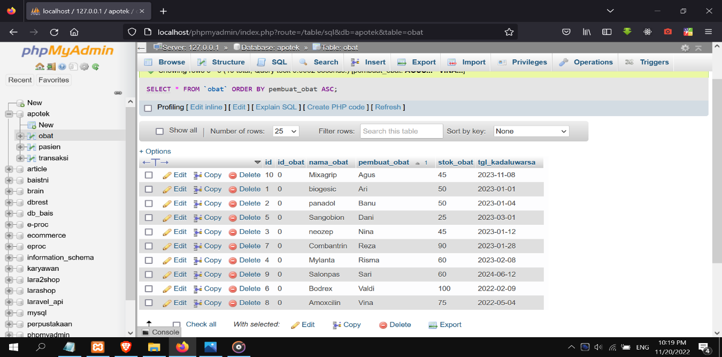

1. SELECT * FROM `obat` ORDER BY nama_obat DESC

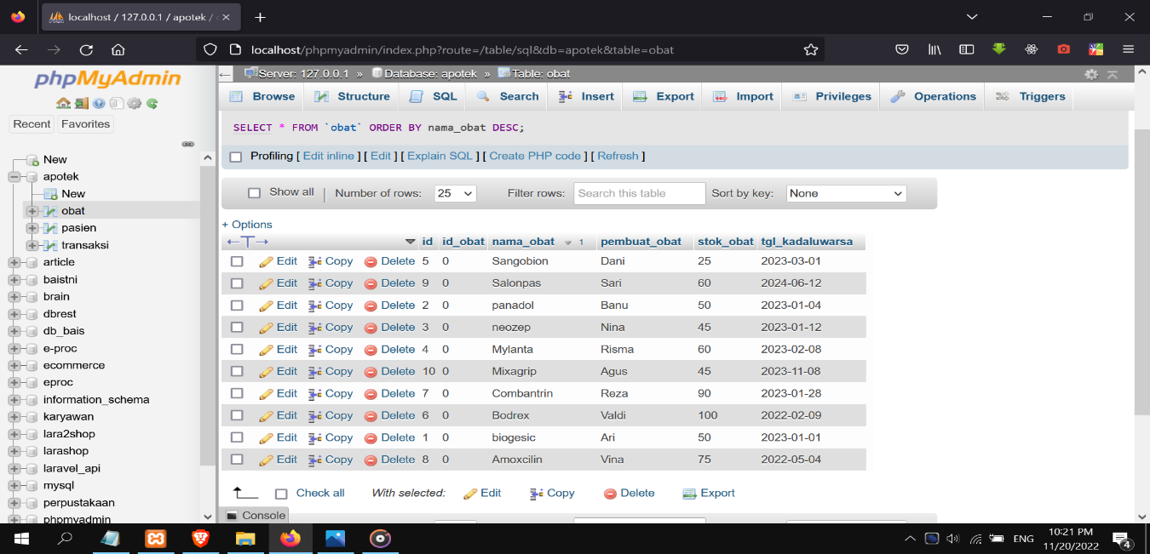

1. SELECT * FROM `obat` WHERE nama_obat LIKE '%s%'

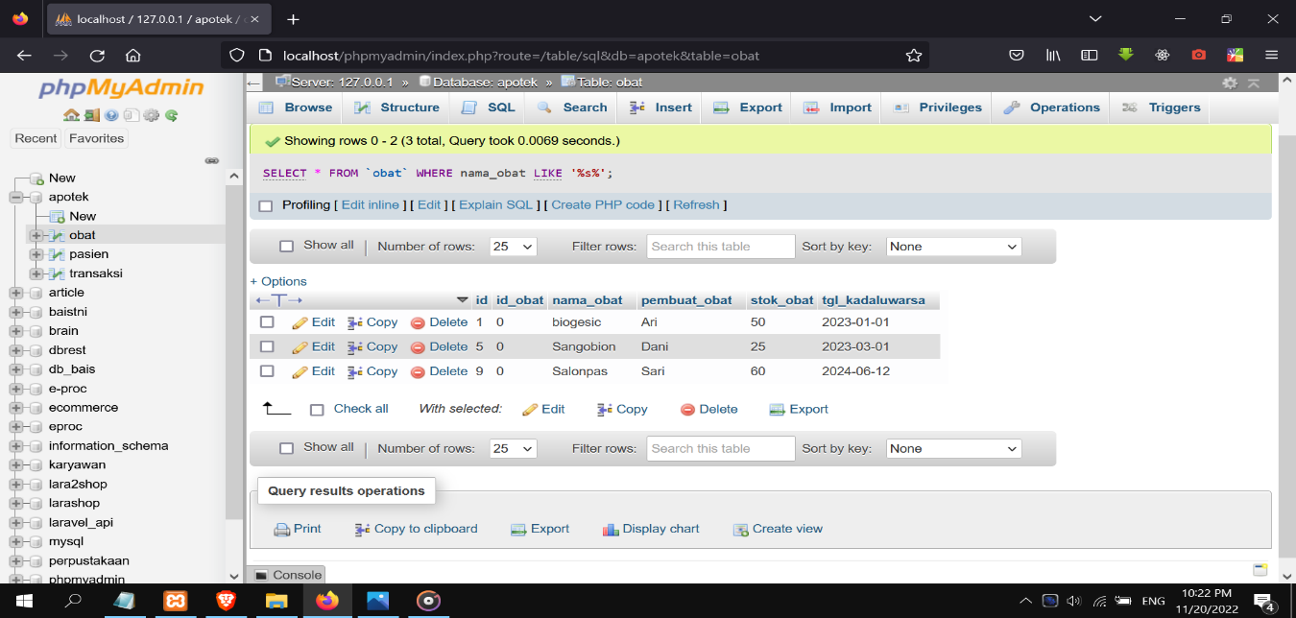

1. SELECT nama_obat, pembuat_obat FROM obat

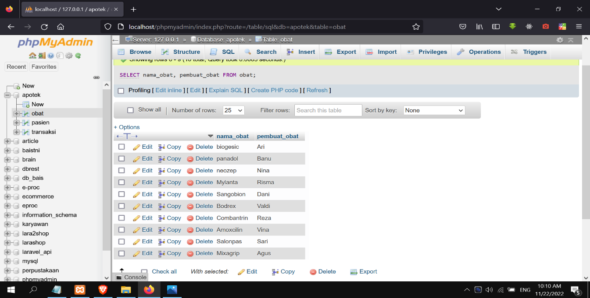

1. SELECT * FROM pasien WHERE (tanggal_lahir_pasien BETWEEN '2012-11-08' AND '2017-10-11')

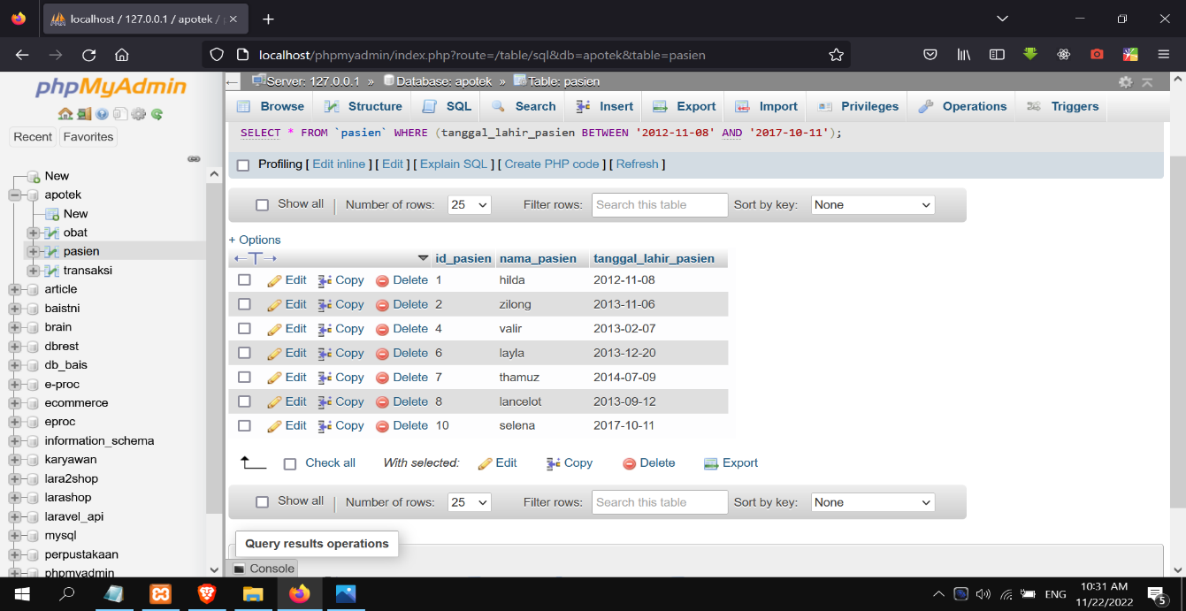

1. SELECT DISTINCT stok_obat FROM obat

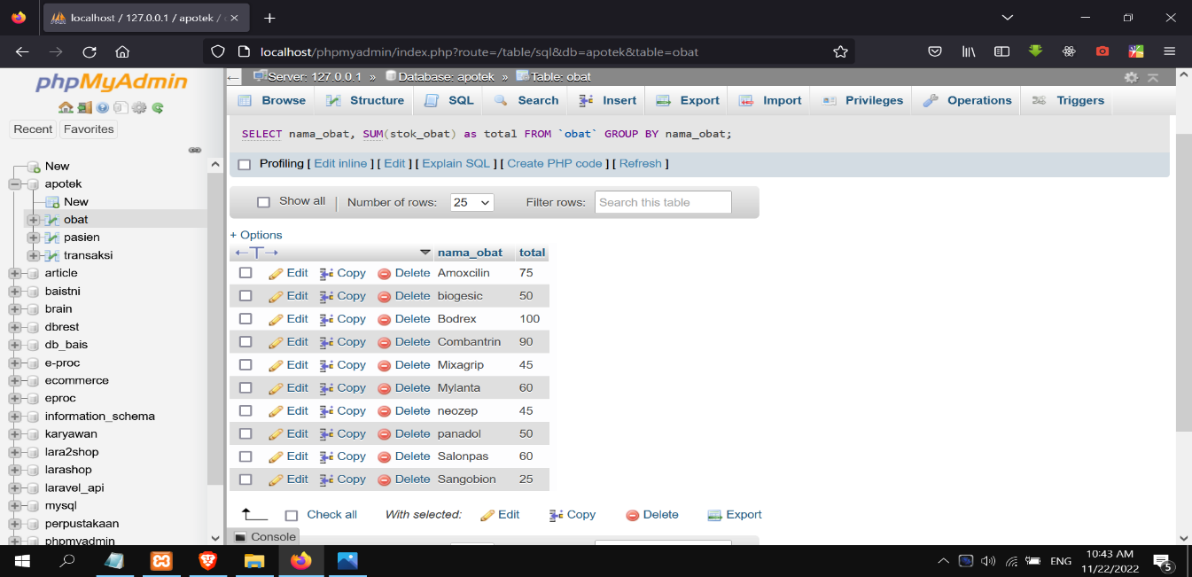

1. SELECT SUM(stok_obat) AS total_stok FROM obat

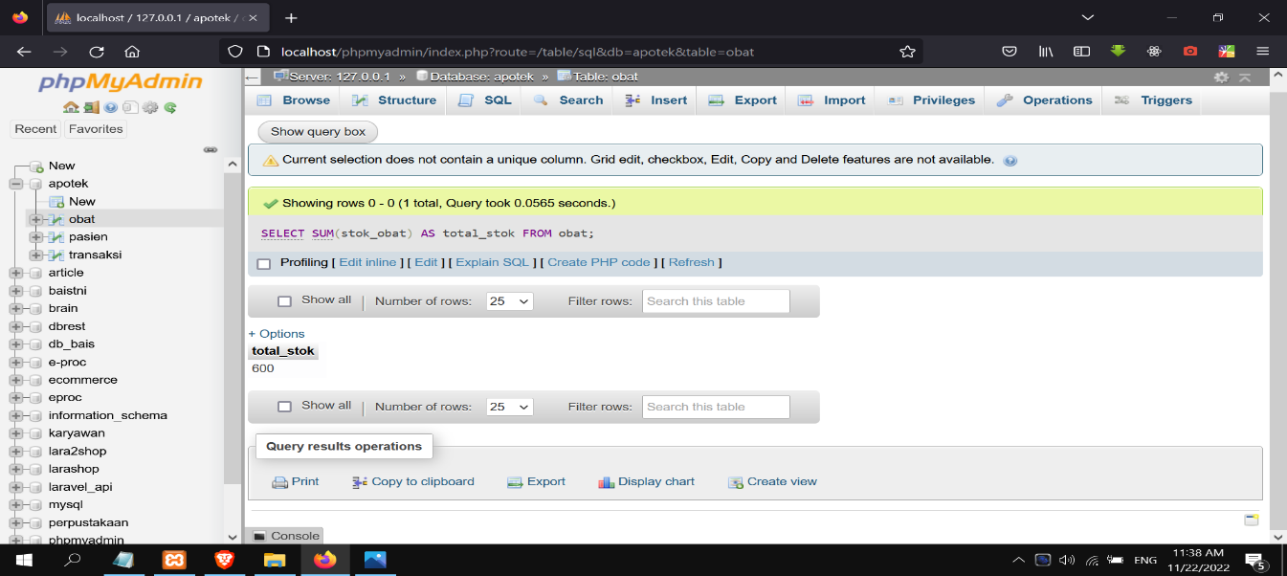

1. SELECT YEAR(tanggal_lahir_pasien) FROM pasien

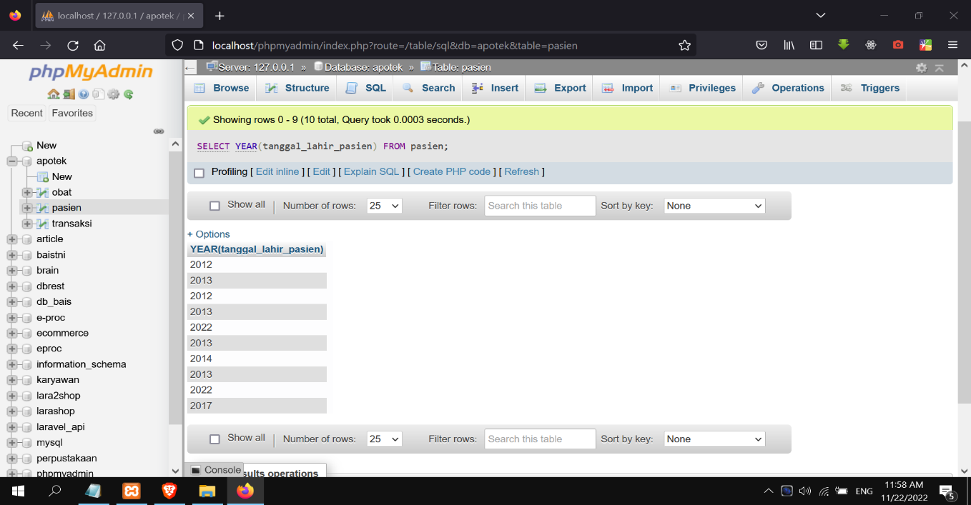

1. SELECT * FROM `pasien` WHERE nama_pasien LIKE '%i%'

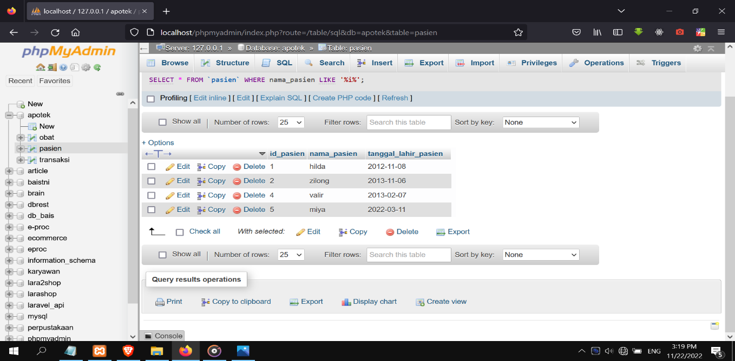

1. SELECT * FROM obat

